**Lab overview -**

This document is designed to give you a walkthrough for performing lab using IBM Data Science experience, Watson Machine learning and Object Storage on IBM Cloud.

The exercise makes use of financial data made available from the open source database available related to credit card customers.

The dataset can be downloaded from - <https://github.com/IBMDevConnect/IBMCodeDay-2018>

**Prerequisite -**

In order to complete the lab, you need to have an active account on IBM Cloud with access to US South region. (Access can be obtained by using a promo code or applying credit card details)

**Steps to perform the lab-**

1. Create an instance of Data Science experience service from the Catalog of IBM Cloud.

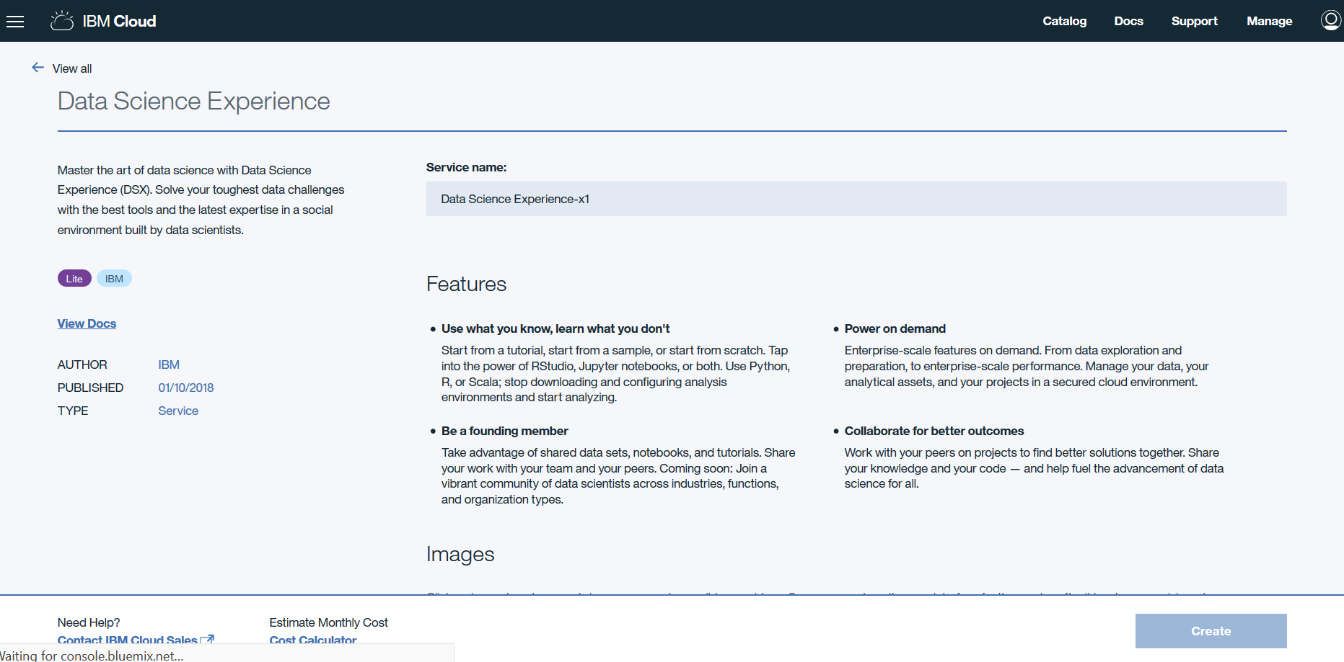

1. Once the DSX instance is created, click on Get Started to launch the IBM Data Science Experience platform.

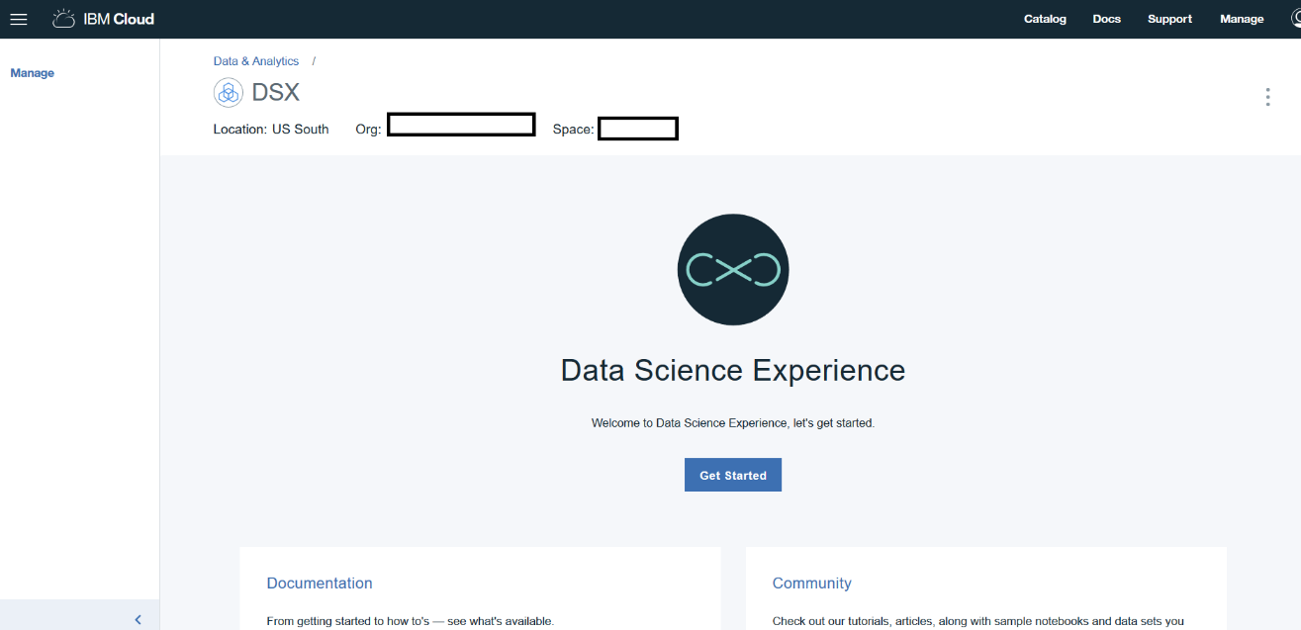

1. As a part of configurating the platform, the DSX will assist in creating following services on IBM Cloud required by DSX –
   1. Cloud Object Storage
   2. Spark
   3. Machine learning service

Please ensure that appropriate service is created with associated lite plan before proceeding further.

1. Create a new project to get started.

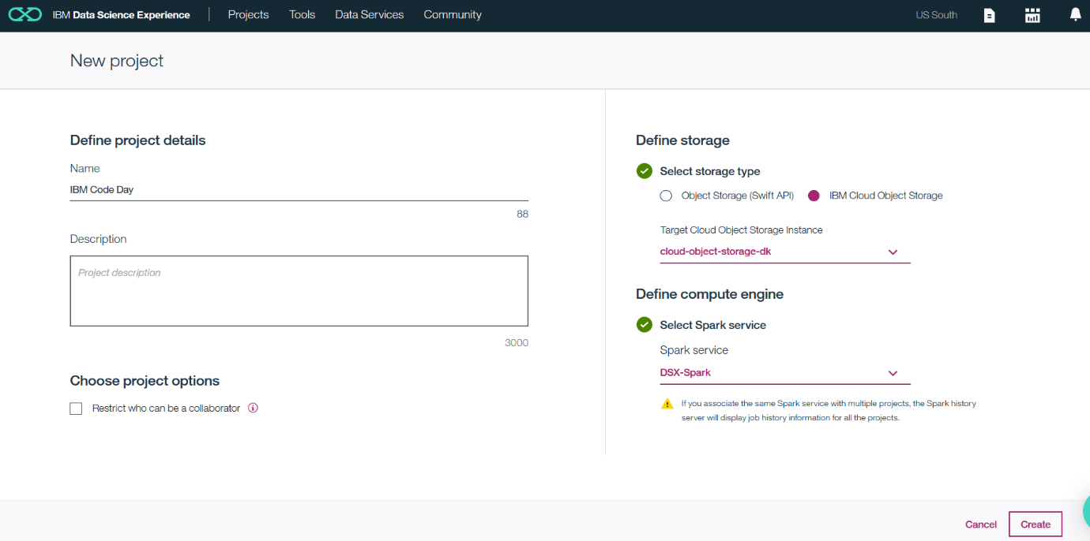

1. Once the project gets created, familiarize yourself with the interface and tabs on the platform.

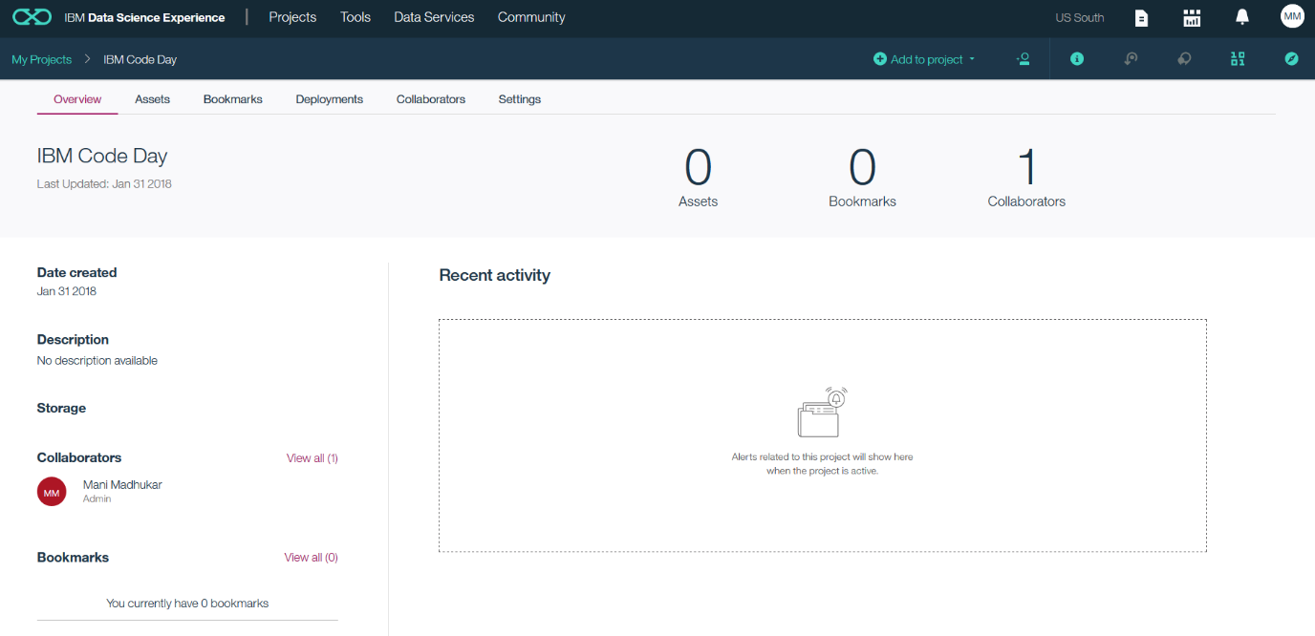

1. We are looking to leverage the model functionality provided by IBM DSX. Select Model option.

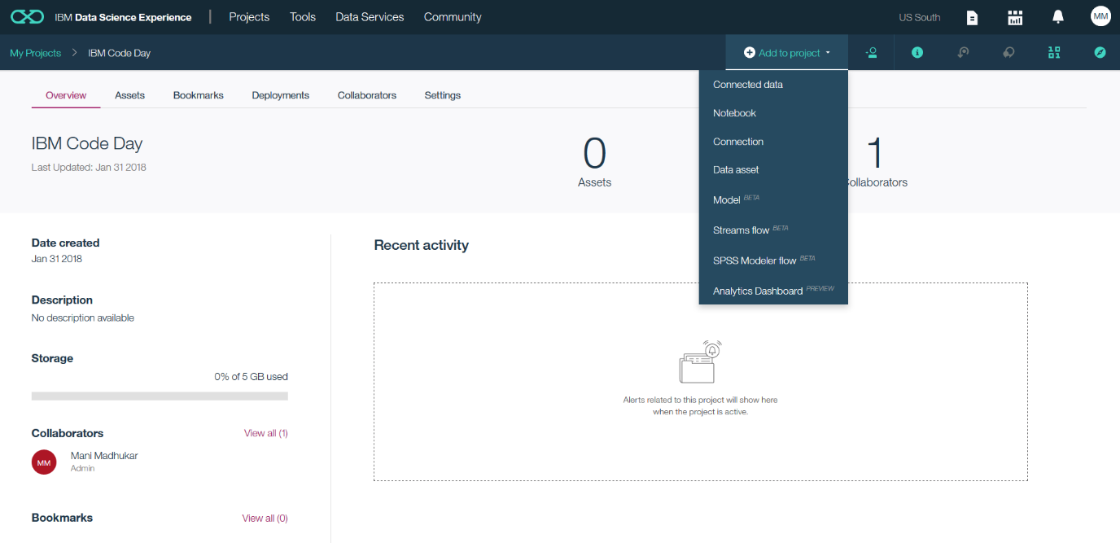

1. First time there will be no Machine Learning Service associated with project. To associate click Associate a Machine Learning service instance link provided under Machine Learning Service section.



1. Create new Machine Learning service instance in case if you not created (step 3) or select Existing tab to associate existing Machine Learning service instance.



1. Click Reload to get Machine Learning service instance populated.



1. Define the various details like naming the model and selecting whether you would like IBM DSX to use Automatic mode or manual. For the sake of ease, we are using the Automatic model approach.

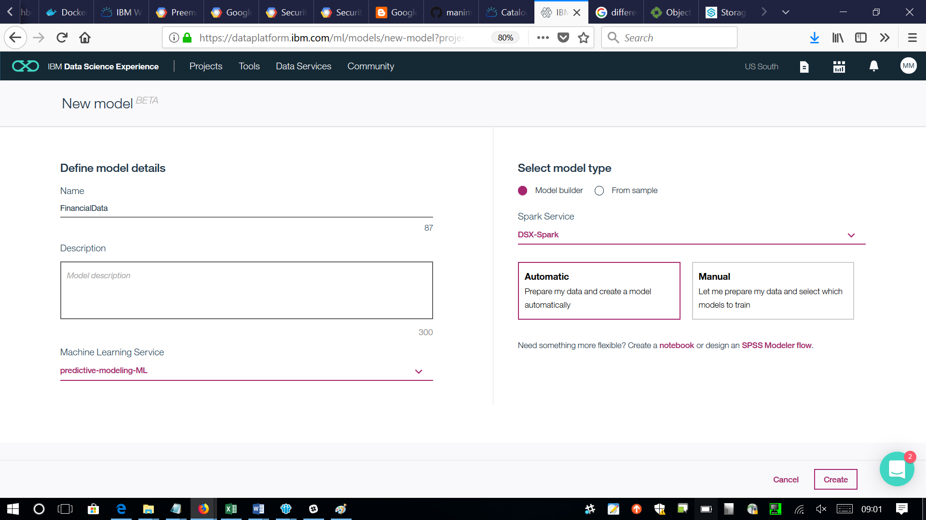

1. Add the Data source to project to build the model for. The dataset will be used to build and train the model.

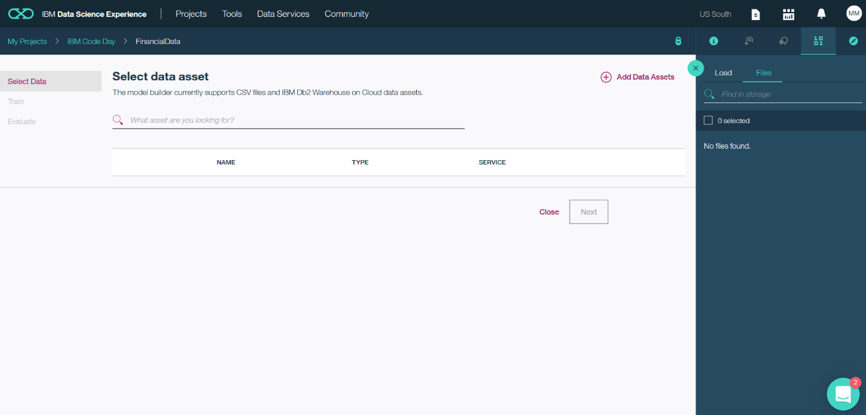

1. Notice that the data is being loaded.

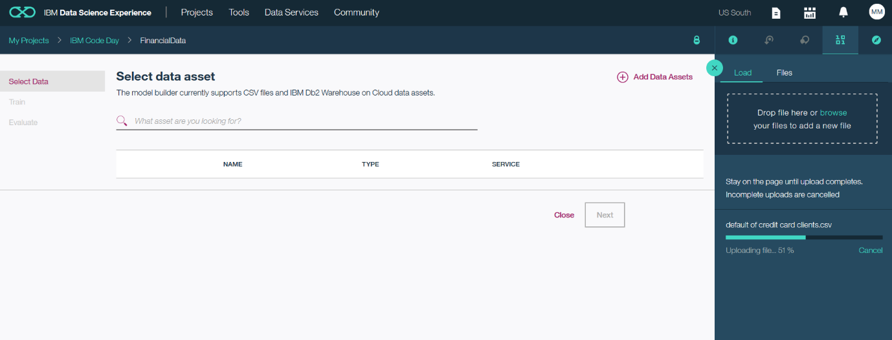

1. Once the dataset is loaded, it will be listed on the DSX platform.

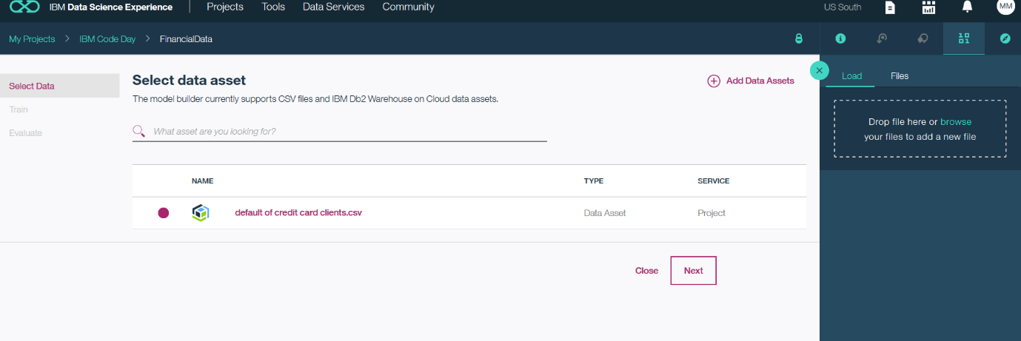

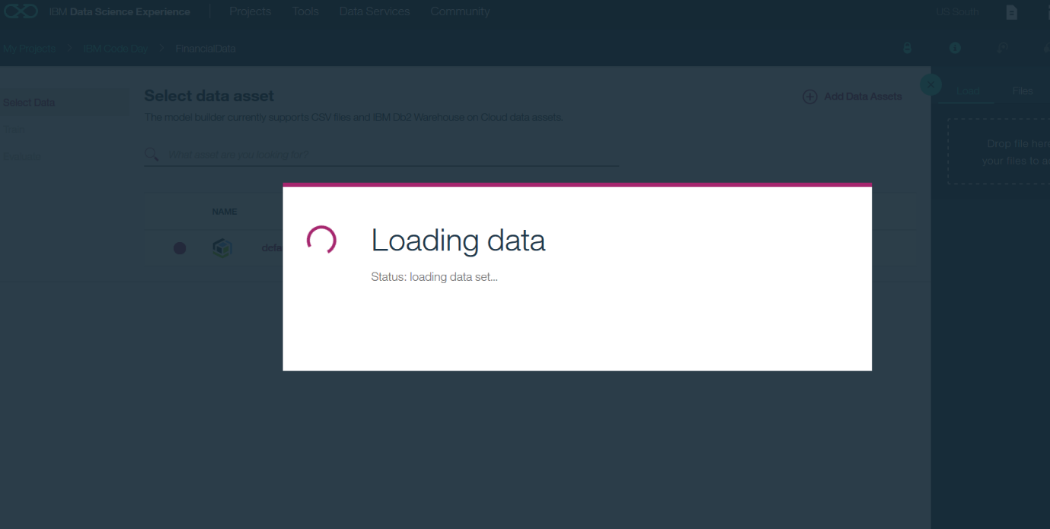

1. Select the field for which the prediction is to be made. Remember the second field refers to All default to take into account the remaining data fields.

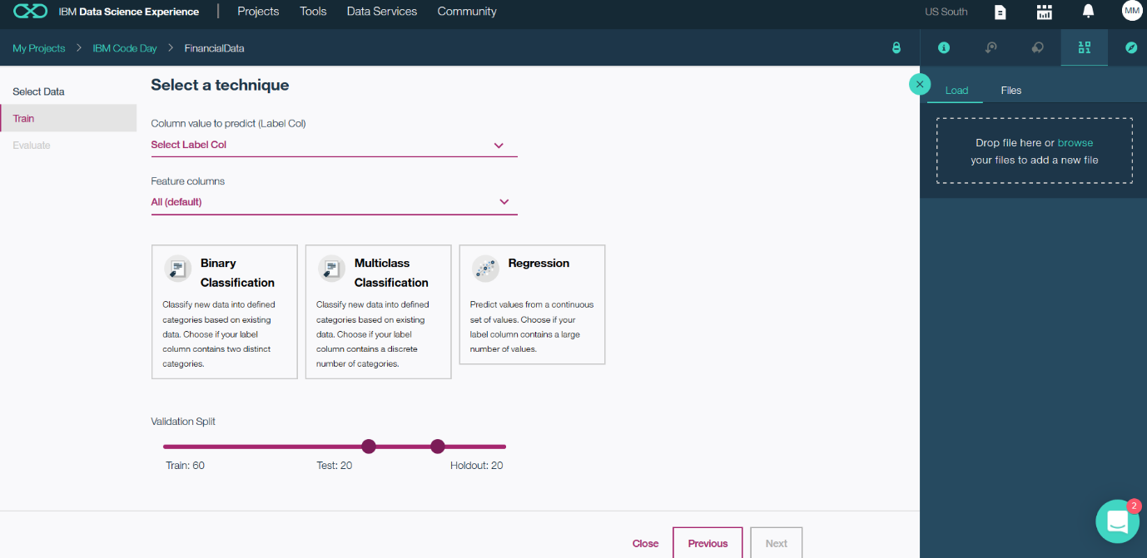

1. Also notice that the DSX, makes a suggestion for choice of algorithm to be used for analysing the dataset. Once done click on Next to proceed with training the model.

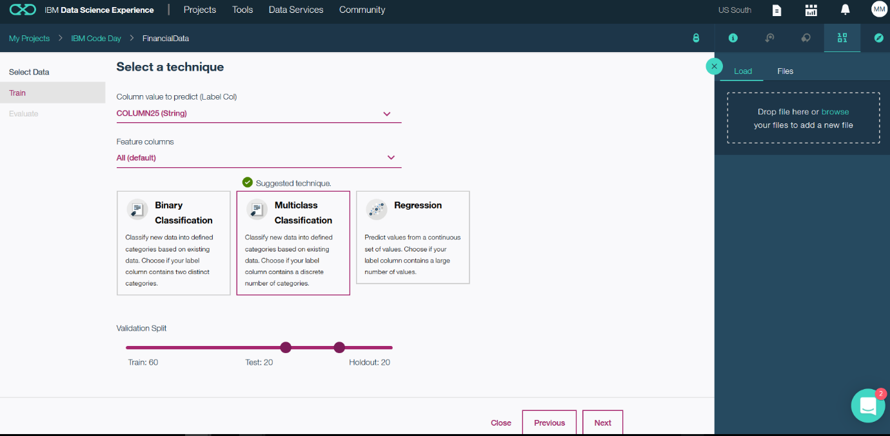

1. The IBM DSX trains the model selected with the data made available to the platform.

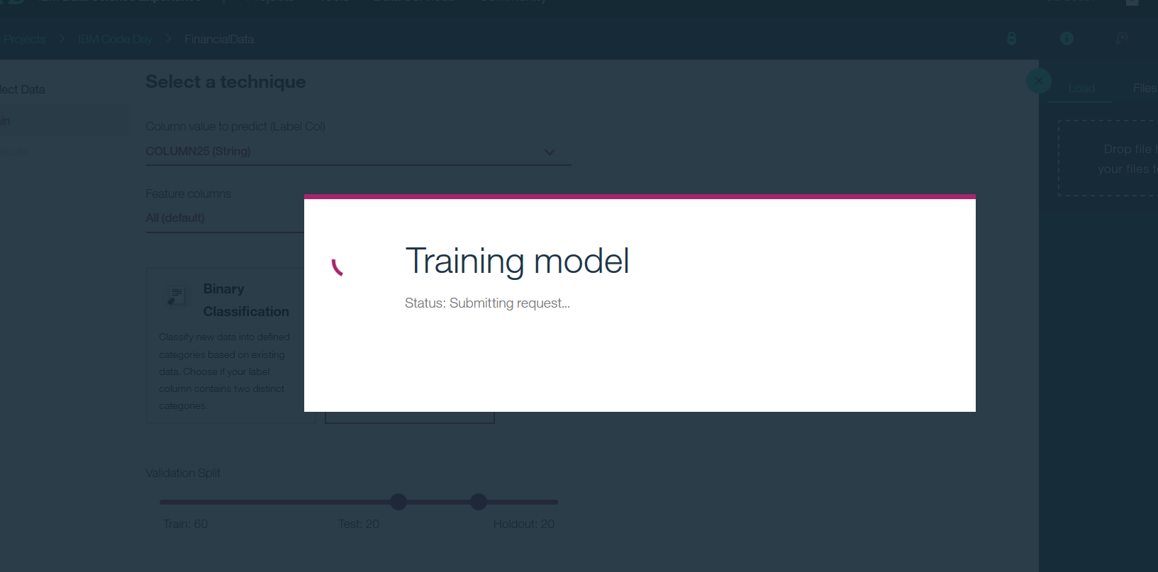

1. Once trained the model displays the statistics about the performance, weighed true positive rate and other parameters.

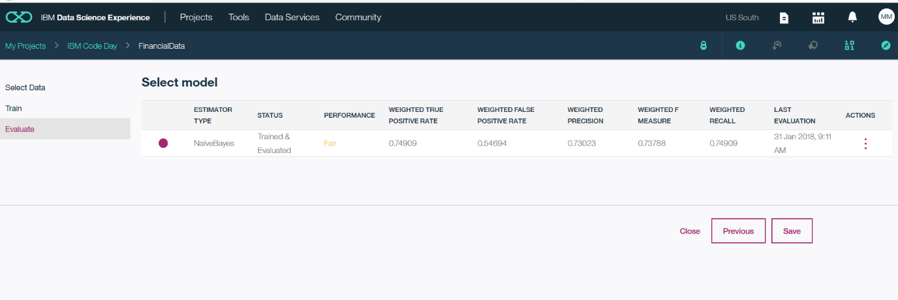

1. Save the trained model for making predictions with test data.

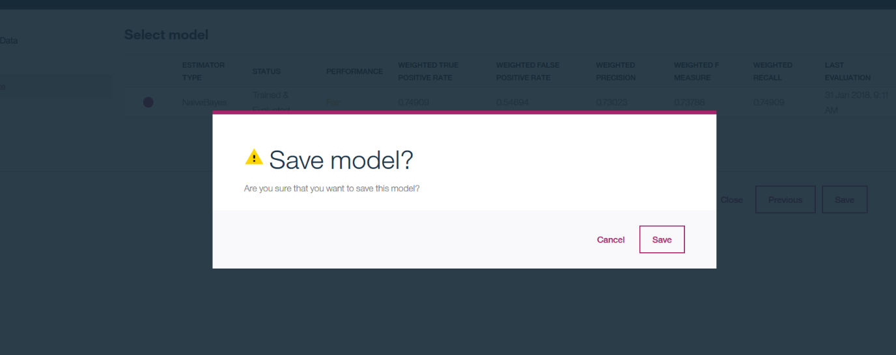

1. Please notice the details about the model trained on the Overview and Evaluation tabs.

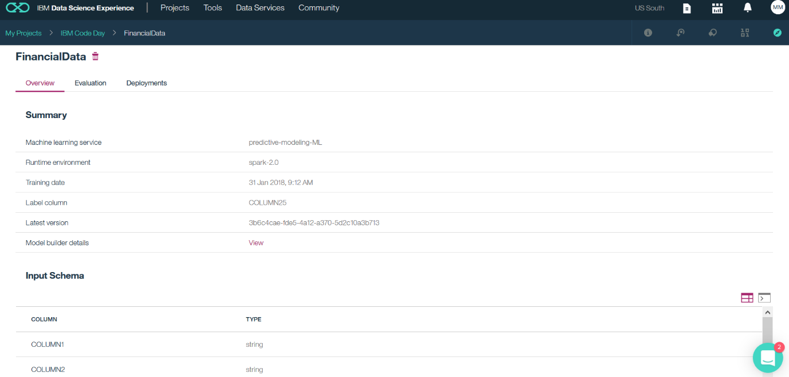

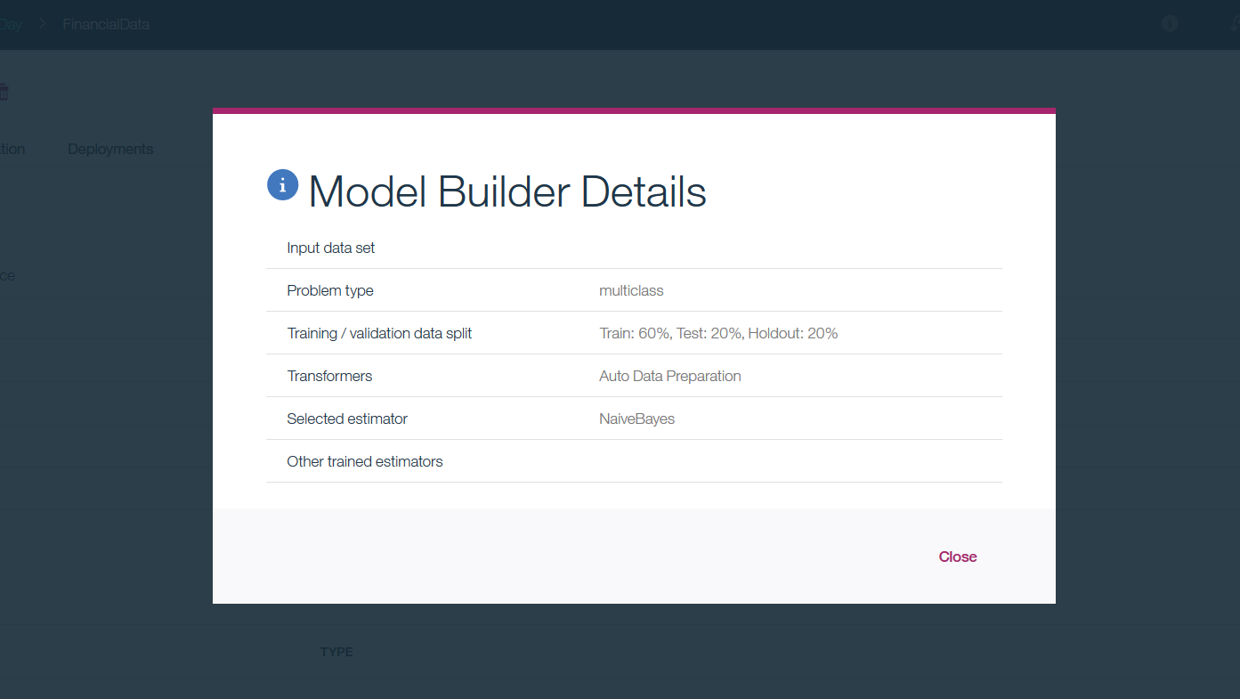

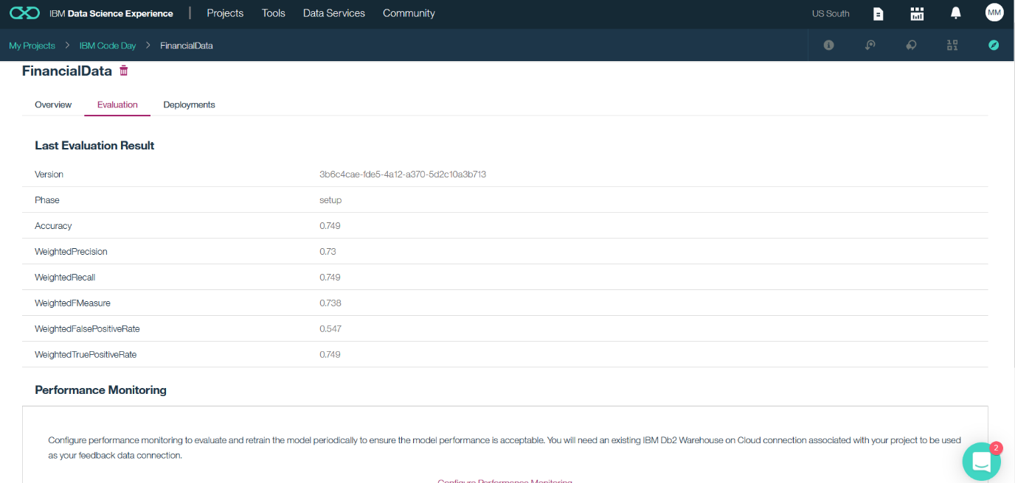

1. We need to deploy the model, click on Add Deployment.

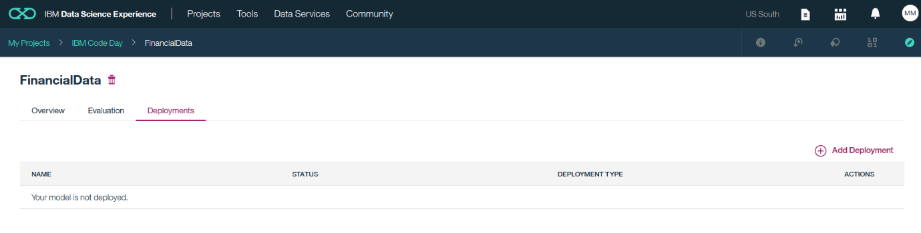

1. Select deployment as Web Service. Provide suitable name to the deployment.

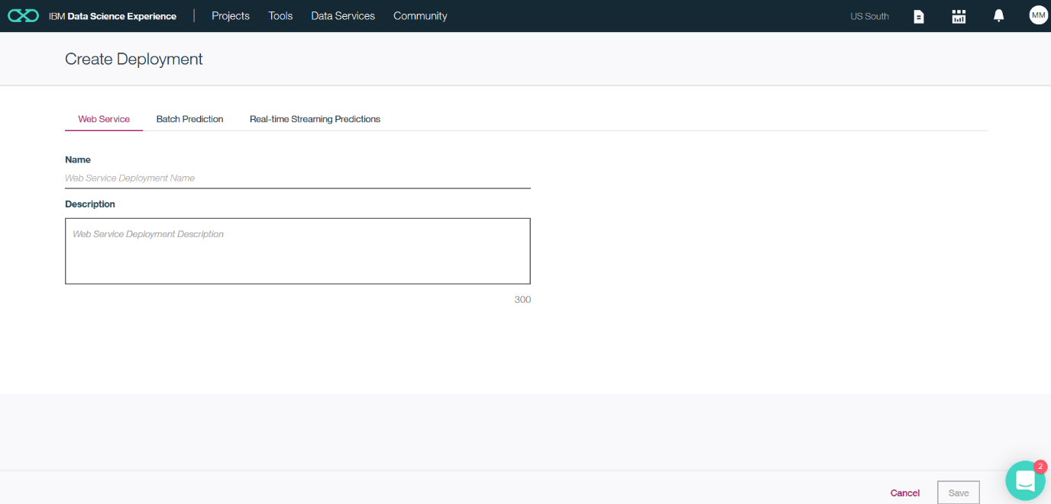

1. Once the model is deployed as web service , wait for initialization post which it will be available as Active.

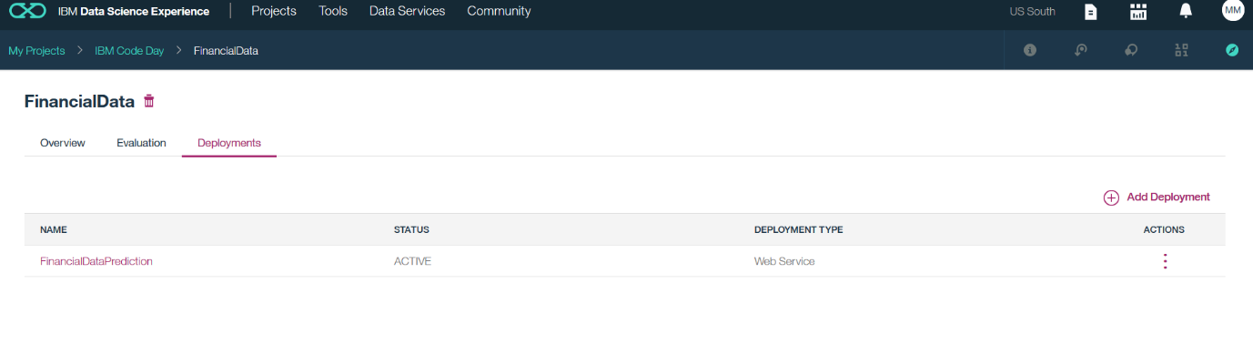

1. Notice the details available on Overview and Implementation tab of the deployed model.

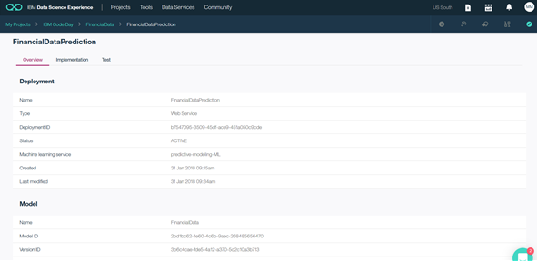

1. The model provides code snippets in various programming language to embed in application for execution.

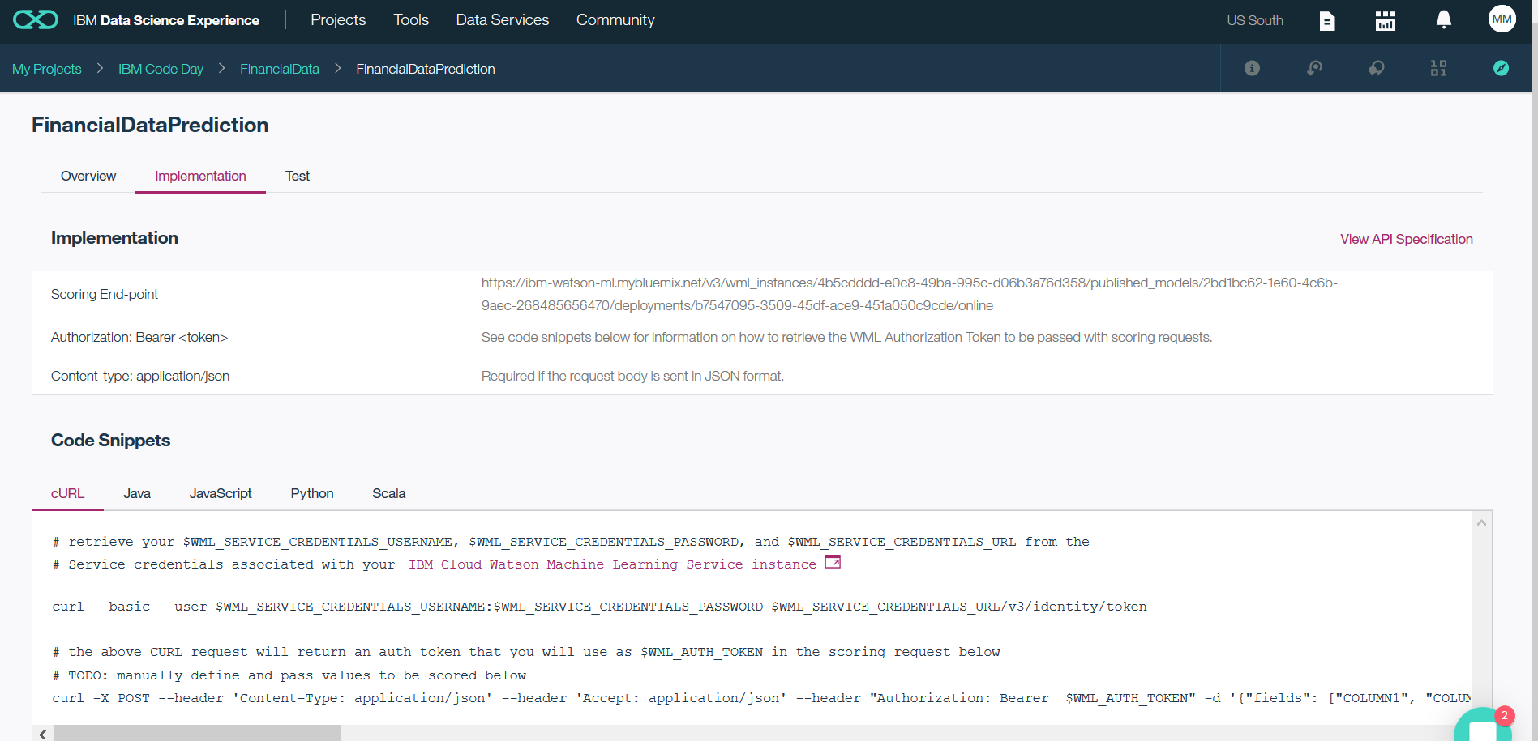

1. Go to the Testing tab, and provide relevant data and click on Predict to see whether the test data for customer will default at the credit card payment for the forthcoming month.

